ORDER OF SERVICE FOR PENTECOST XIX

September 14, 2008

THANKSGIVING SERVICE

Organ Prelude
Trumpet Fanfare …………………… Bernard Haynes
Processional Hymn ……………… # 298
Opening Sentence ……………… B.C.P. Page 100
Salutation and Collect for Purity ….. B.C.P. Page 101
The Kyries and Gloria ……………… B.C.P. Page 102
The Collect ……………………………….. B.C.P. Page 178
The Old Testament Lesson ………… Ecclus.27:30-28:7 Family Member
Solo ……………………… Nina Maloney
The New Testament Lesson ………. Rom.14:5-12 Family Member
Gradual Hymn ............................ # 657
The Gospel …………………… Matthew 18:21-35
The Sermon ……………………. Fr. Sylvanus Regisford
The Peace ……………………… B.C.P. Page 124
Citation from the Queen ………… The Governor General Greetings: …………………… Well-wishers
Presentations:
Mother Jack’s Response
Offertory Hymn ……………………… To God be the Glory
Offertory Prayer ………………... B.C.P. Page 126ff
Sursum Corda ………. ……… B.C.P. Page 126
Eucharistic Prayer …………………. B.C.P. Page 131
The Lord’s Prayer ………………… B.C.P Page 144
The Invitation ………………… B.C.P Page 145ff
The Agnus Dei ………………… B.C.P Page 147
Communion Hymns ………………… 555, 549, 421, 321
Post Communion Prayer …………… B.C.P. Page 147
The Blessing
The National Anthem
Trumpet Blast
Final Hymn …………………………. #379
Dismissal
Organ Postlude

To God be the Glory Great is Thy Faithfulness

To God be the Glory! Great is Thy faithfulness
great things He hath done O God my Father,
So loved He the world there is no shadow of turning
that He gave us His Son; with Thee;
Who yielded His life Thou changest not,
an atonement for sin, Thy compassion they fail not
And opened the life gate as Thou hast been
that all may go in. Thou for ever wilt be.
Praise the Lord, praise the Lor Great is Thy faithfulness,
Let the earth hear His voice; great is Thy faithfulness;
Praise the Lord, praise the Lord! Morning by morning
Let the people rejoice: new mercies I see;
O come to the Father, All I have needed
Through Jesus the Son Thy hand hath provided -
And give Him the glory; Great is Thy faithfulness,
Great things He hath done! Lord unto me!

O perfect redemption, Summer and winter, and
the purchase of blood! spring-time and harvest
To every believer the promise of God; sun, moon and stars in their
The vilest offender who truly believes, courses above,
That moment from Jesus join with all nature in
a pardon receives manifold witness
Praise the Lord…… to Thy great faithfulness,
mercy and love
Great things He hath taught us, Great is Thy faithfulness …
great things He hath done,
And great our rejoicing Pardon for sin, and a
through Jesus the Son; peace that endureth,
But poorer, and higher, Thine own dear presence
and greater will be to cheer and to guide;
Our wonder, our rapture, strength for today and
when Jesus we see bright hope for tomorrow,
Praise the Lord…. Blessings all mine, with
ten thousand beside!
Great is Thy faithfulness…

Greetings from the Ven. Rev. Dr. Sylvanus Regisford

Our Centenarian
Mother Gwendolyn Jack
Father Lionel Richards who is himself musically blessed, suggested to me late last year that it would be a wonderful thing for us, as a Church, to join together to help Mother Jack’s family to celebrate her hundredth Anniversary of birth; and he suggested two (2) important factors in such a celebration – (a) Mother Jack would play the organ during the Service, at one point or the other. (b) The Governor General should be asked to attend and read again the Citation from the Queen.

I thought it was a capital idea. After all, the Church is steeped in celebration of life, recovery from illness, victory over adversity, and the attainment of important milestones in the life of the Church as a whole, and in that of individual members.

We can say, “the rest is unfolding itself now in this rejoicing in the power of the Human spirit to soar above sickness and tragedy and with the reliance on the strengthening power of the Holy Spirit, to achieve remarkable feats which lesser mortals cannot accomplish.

And so, I salute Mother Jack at this time; and I know that all her accomplishments are well documented and do not need to be rehearsed by me. The one thing I can say, that is so important to all of us, is that she is “par excellence” a “people person”; and she genuinely loves us all, and this love is reciprocated one hundred-fold.

May she continue to enjoy good health, and may God continue to bless her in every which way.

Peace and love

Sylvanus Regisford,
Rector

Greetings from Canon Hoskins Huggins

Tribute to a gracious Lady

It gives me very great pleasure to send Greetings to a most gracious lady on the occasion of her 100th birthday.
I have known Mother Jack all my life. She has impressed me with the loveliness of her life, and the beautiful Christian she is; always with a comforting word, and encouragement for all who come in contact with her. A truly exemplary life!
Mother Jack learnt early in her marriage that in the family it is the children that matter most, and for their happiness and healthy development they need a permanent and stable home. There is no substitute for the home. The home is a training ground in character. What a child turns out to be depends very largely on the influence of the home. It was the children who mattered most; and she brought them up in the fear and love of the Lord. She taught by example. She believes that it is not what you say, but what you are, that will influence the children in a right or wrong direction, without a word spoken. So for her children's sake she consecrated herself. She knew that God had placed in her hands a peculiar privilege which carried with it great responsibility - that is, to bring them up for God; to train them for heaven; and to teach them values which would endure as long as life endures.
Mother Jack is a devoted Christian and a great woman of prayer. She did not send the children to Church, she brought them. Her home was a home where God and his Church came first.
So dear mother Jack rejoice in your accomplishments celebrate your blessings; glorify your Creator. He is smiling on you today as you celebrate your 100th; wishing you a future filled with blessings, and all the happiness you deserve. To God be the glory!
A. Hoskins Huggins (Canon)
****************************
Greetings from Rev. Dr. Lionel Richards

Mother Gwennie is a true mother figure to me. She and my mother were born in the same year (1908) one in Antigua the other in St. Vincent; both had sons born in the same year (F.I. and me who taught together with him as Principal); both named one of their daughters Yvonne. In music, Mother Gwennie with her musical skills, could easily have played the part of teacher that my father played in my early years. Providence brought me from Antigua to St. Vincent to connect with this family. God richly bless you Mother Gwennie.
Father Lionel Richards.
*****************************
Mom, today September 11th, 2008, marks ONE HUNDRED YEARS since the Almighty
placed you here on earth. What a blessing! What a milestone! It is indeed our pleasure to salute you as one of the special women cited in Proverbs 31:10 – 31.
Unfortunately we cannot be there in person with you, but you can rest assured that we are there in spirit. Enjoy your BIG DAY. We join you in giving ALL the praises and glory to God.
We thank you Lord for giving us your best. Thank you Mom for giving to the Lord.
Janet & Ewan (Lewis), Toronto
Greetings from Rev. Fr. E.Ulric Commissiong-Jones

It is with much joy that Marilyn and I send you these affectionate greetings on the occasion of your 100th Birthday.
We regret very much our absence on this most auspicious occasion. This is due to an invitation from the church of St. Anne’s in Bermuda, asking me to do a locum with them for the month of September.
We both, children of Calliaqua and our beloved St. Paul’s Church were influenced by your example over these many years. We recall your involvement in the life of St. Paul’s in its varied spheres and your abiding cheerful countenance and charm.
It was you, Mrs. Jack on behalf of the Mothers’ Union of St. Paul’s, who designed and made the chasuble, stole, burse and veil as a gift to me on the occasion of my ordination to the Sacred Order of Priests on August 7th, 1977, at which you were present.
You were also present as I celebrated the first Holy Eucharist as a newly ordained Priest, right here at St. Paul’s our spiritual home on August 9th, 1977.
For your Christian witness and example, all that you have done and continue to be and all that you are to all of us who regard ourselves as your extended family, we say a sincere thanks to you.
We share the joy of this day as you are surrounded by your children and grandchildren, by your relatives, friends and the St. Paul’s community of faith. “This is the day that the Lord has made, we will rejoice and be glad in it.”
We wish you every Blessing on this your centennial birthday and pray God’s richest Blessings upon you. I shall remember and pray for you at the altar as I celebrate the Holy Eucharist on Sunday, September 14th, in Bermuda.
May Almighty God grant you continued good health and may He bless you in the days and years ahead.
Fr. E. Ulric & Marilyn C. Jones
*****************************

I consider it a great privilege to be able to extend greetings to Mrs Gwendolyn Jack on behalf of the Girl Guides Association of St. Vincent and the Grenadines and by extension the World Association of Girl Guides and Girl Scouts of which we are all members.
Mrs Jack celebrated her 100th birthday on September 11 and it is my belief that she is our oldest living Guide. She was one of the first members of the 1st Calliaqua Guide Company and I am sure that the values instilled through Guiding during those early years of her life have helped in some way to mould her into the wonderful lady that she is today.
As an adult, Mrs. Jack volunteered as Captain of the No. 5 Guide Company in Callaqua. She was also a member of the Trefoil Guild and a member of the Council of the Girl Guides Association for many years.
Today we join with the parishoners of St. Paul's Anglican Church to give thanks to God for her life and achievements.
Our heartiest congratulations, Mrs. Jack, on achieving this great milestone. May the good Lord continue to shower you with his blessings.
Althea Commissiong
Chief Commissioner
Girl Guides Association of St. Vincent and the Grenadines
Family means everything
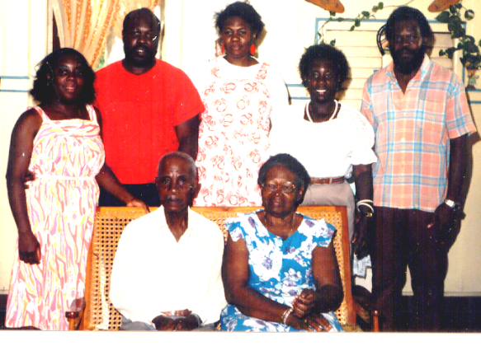
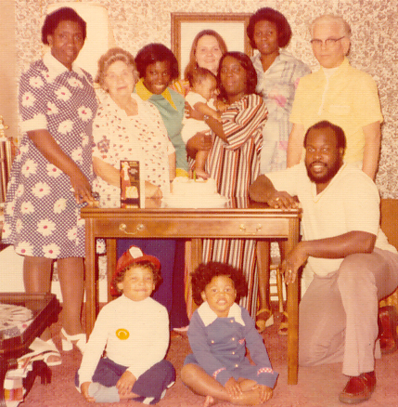

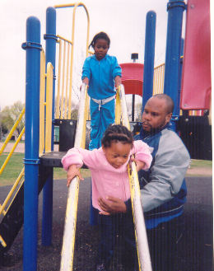 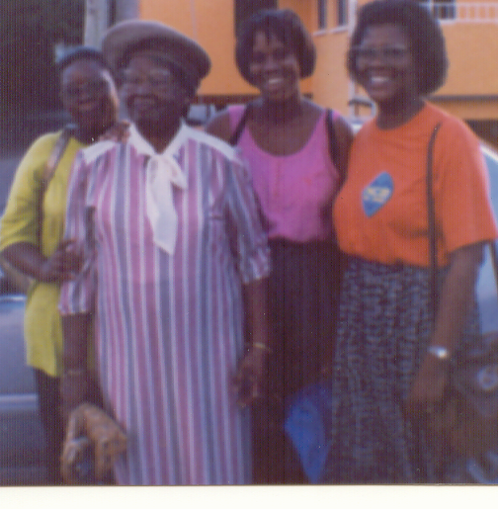 Grandson and great grands Daughter –in-law and granddaughters
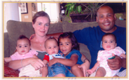
Grandson and great grands Granddaughter
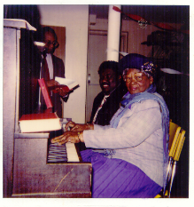
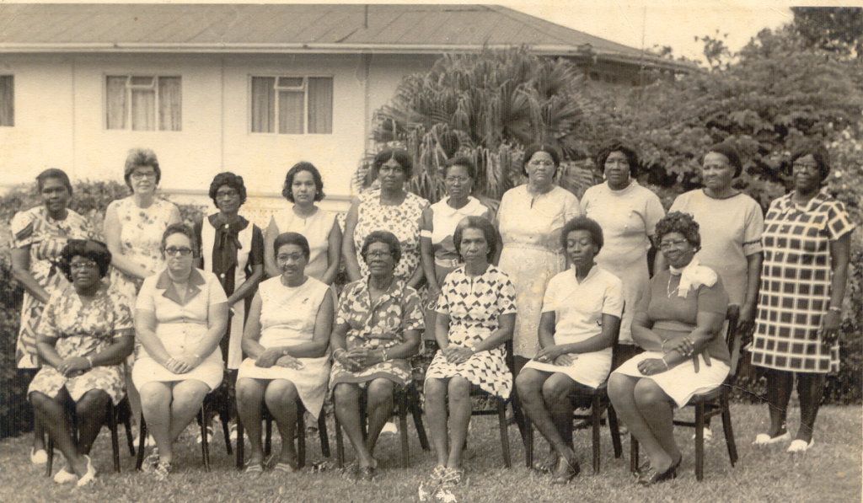

Mothers’ Union Leaders in the 1960’s At St.Luke’s Church,Toronto
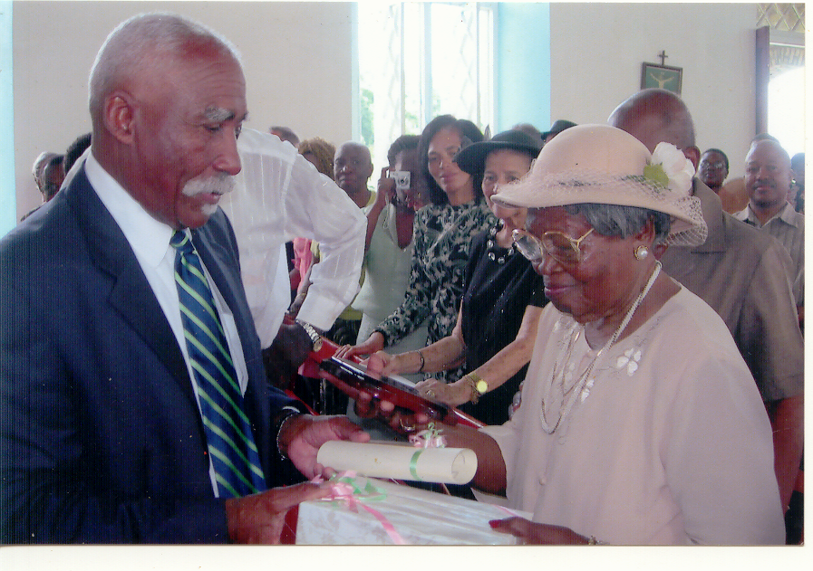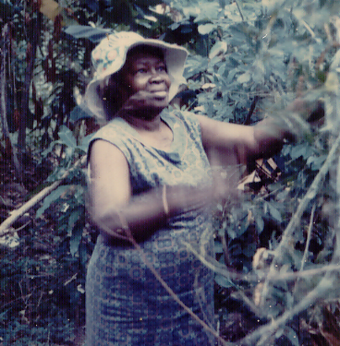
Receiving award from Gov. Gen, Tending her garden 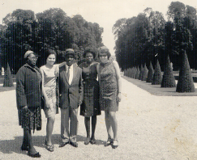 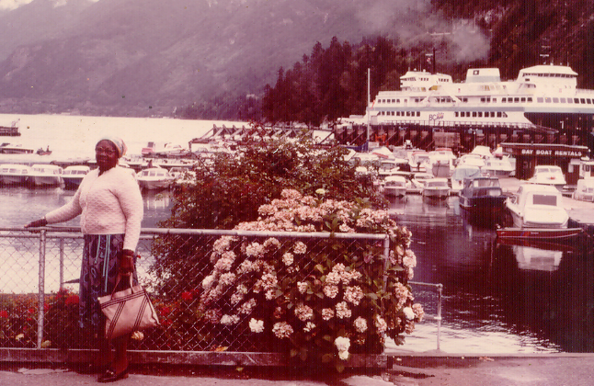
Vacationing in Versailles, France Visiting Niagara Falls, Canada

Greetings from Villagers:

We would like to extend happy 100th birthday greetings to Mother Gwennie Jack. We want to thank her for her positive contributions to humanity. We love and appreciate her and pray that God may continue to richly bless her.
Love.
Cheryl (Phills) King & Family & The Phills Family, U.S.A

**************************************
Nennie Jack, as I know her is the oldest living member of my extended relatives. She has been one of my pillars and role models that has helped me to become the person I am today. I thank God for the hard lectures and scolding I received from both her and my Grandmother (Beatrice Pemberton now deceased). If I didn't get it from one I got it from the other, and in those days there were no cell phones. At the time I did not understand some of her parables and reasoning but as I got older, I became wiser and today I am a better person. Nennie Jack, thanks also for teaching me how to knit, crochet, make fudge, sandwiches, care for community, plants, and I can go on and on. You have always been there for me unconditionally. My husband Crispin and daughters Krisann and Christine Friday join me in wishing you much love, happiness and God's continued blessing on your 100th Birthday.
Regards,
Ancilla (Pemberton) Friday, U.S.A

*****************************************************

Hi Auntie Gwenie:
The Davis girls: Miriam, Kathie, Hazel, Stella, Lottie, Ali along with
June Arthur extend birthday greetings to you on this most wonderful day of achieving 100 years. You have touched our lives in so many positive ways and we are so privileged to have had your influence on our lives. The many times spent making lime balls, Easter bonnets, scrap mats and pin cushions are fond memories which we still treasure today. May the Lord continue to keep you and bless you. Mommy and Irene are there to give you good wishes in person.
Much love from all of us.

***********************************
Dear Mother Jack
Congratulations on this momentous occasion of celebrating your 100th Birthday. Your love for the children in the Village still remains strong in my heart. May the Lord continue to bless you richly. Please accept love and best wishes from Joan and myself.
Chris Stephens, Montreal

Dear Mother Jack,
Congratulations on your 100th Birthday. Sorry I can't be there to celebrate
this amazing day with you, but I will be thinking about you.
May God continue to bless you with good health and keep you strong.
Have a Great Day.
In His Love
Carmen Phills, Toronto
************************************
Mother! What a good "Old Soul" you are! But is the soul ever old? that part of you that creates opportunities to help others, that sees the need to forgive others, that kindles a deep and profound desire to be tolerant of others, that opens and whets the appetite of your compassion for others, that humbles you, is God's special gift to you. How well you have used your gifts, how well you continue to use them in appreciation of God's love for you; to the point of accepting Jesus Christ His Son as Lord and Saviour of your life and to be filled with His Holy Spirit. I therefore salute you, mother dear.
As I think of you, mother, the words of the wisest man who has ever lived come to mind-Solomon's Proverb, chapter 31: 10-31. Although the entire passage speaks of you, mother, I will refer to verses 20, 22, and 25-30- they are poignant. It is all about you, your nature, your character, your life. "She opens her hand to the poor, and reaches out her hands to the needy." Many are not aware of the many you have helped along the way: emotionally, spiritually and economically. "She makes herself coverings; her clothing is fine linen and purple." The many things you have knit for others and the beautiful dresses you make for yourself and others, and the beautiful gift you made for Grace is testimony one of your many gifts. Many can testity about them.
I love you, mother. We all love you, mother. But mother, God first loved you. May God bless you and keep you, may God cause His face to continue to shine upon you and to be ever gracious unto you, may God grant you the favours you so desire, may God grant you peace. A very, very, very happy birthday to you. Amen
in John 14: 27, Jesus said: "Peace I leave with you; my peace I give to you. I do not give as the world gives. Do not let your hearts be troubled, and do not let them be afraid." "Blessings."
In Christ,
Henry Stephens
***************************
The Dougan family extends sincere birthday greetings to ‘Mother Gwennie’ on her 100th birthday. We are very fortunate to have been her neighbours for the greater part of our lives and would like to think that some of her many attributes have rubbed off on us over the years.
She claims that she first met our mother, Edna when she (Gwennie) arrived here from Grenada at the age of 7, our mother being then 2 years old. They both got married and ended up living next door to each other where they shared their triumphs and their trials with much love and grace. As the saying goes “it takes a village to raise a child”, in her case, it could have taken only her to raise a village. Wish you many more beautiful years, Mother Gwennie. God bless.

This is an Ode to my Godmother Mrs Gwendolyn "Nennie" Jack, born
AD 11th September 1908 on the Spice Island of Grenada, Windward Islands.

G - is for a Gracious, Gentle, God-fearing individual

O - is for One because there is only one of her kind

D - is for the Day I took my family to meet my godmother recently and their delight at listening to her stories of her experiences and her life home and abroad. The distinct memories following that visit continue to be a talking point in our household and beyond

M - is for Motherhood, a gift, a blessing which Nennie Jack demonstrates with pride, love and dignity. M is for the manner in which she has moulded her children, grand-children and god-children and helped to make us who we are today

O- is for Others, the time she still manages to give to others, her oratory skills, her openess

T - is for her Trust in God, a teacher, a talent, and that she continues to touch the lives of so many

H - is for HER life, one which I have been honoured to be a small part of, growing up as a child , a young adult and now as a mother and godmother myself

E - is for Everything my godmother stands for, those values and principles which continue to leave their mark on everyone and everything she meets and touches

and finally

R - is for Respect and the high Regard with which she is held. A Righteous and deeply Religious awesome lady. R is for her Reward from her God whom she continues to serve each and every day of her LIFE

God Bless you on Your 100th Birthday and Always

Love and Best Wishes
Auldene (Cochrane) and FamilyXx

Greetings from Mothers’ Union

"How hard it is to find a capable wife! She is worth far more than jewels! Give her credit for all she does. She deserves the respect of everyone." Proverbs 31: 10 & 31
Sister Gwennie, words are not enough to express our thankfulness to you for all you have done. You have been an inspiration to us in so many ways. We may not be able to catch up with you, but we would certainly follow you and with God's help continue the exceptionally good work which you have done for the M.U. As you grow in age, may your wisdom continue to inspire us.
On behalf of our Chaplain, Dean Patrick Mc Intosh, members of the M.U in the Archdeaconry of SVG and my family I wish you a happy and spirit-filled birthday, God's continued blessings and good health. We love you.
Rosemarie Alleyne
President SVG MU
*******************************
I am extremely gratified to be able to witness Gwen’s achievement of this most significant milestone, which very few of us are granted the privilege to celebrate, and even fewer with full faculties intact, as she can boast. As a colleague in the Mothers’ Union for countless years, I salute her sterling contribution to that organization and the Vincentian community we served. I treasure the age-old friendship of this decent, caring, generous, talented and principled individual that Gwen is. On behalf of the entire Norris family, I extend warmest congratulations and best wishes for her continuing good health and happiness.
“Age cannot wither her, nor custom stale her infinite variety.” Anthony & Cleopatra, William Shakespeare.
Irma A. Norris
******************************************
On behalf of the St. Paul”s Mothers’ Union, we would like to extend sincere greetings to Sister Gwennie Jack on attaining this milestone of her life. Being one of the founding members, her love of, and dedication to this organization cannot be surpassed. She remains an active member, attending meetings whenever possible. She participates in, and supports all our functions, if not physically, offering from her vast pool of ideas. Last November, she composed a song which we performed at the Harvest Cantata, accompanied by her on the keyboard to a rousing applause from the audience. She continues to make over a hundred palm crosses for Palm Sunday Service every year and donates hand made decorative hangers for sale at our yearly Jumble Sale. She remains constant in her spiritual living, her peaceful and calm manner, her ability to motivate, her fantastic memory, her detailed story telling , her general love for others --- a person you want to be around. ‘Hats off’ to this remarkable woman, “the Amazing Gwennie Jack.”
Cynthia Huggins and
Irma Dougan
*****************************************
Greetings/Well wishes from St. Luke’s Church, Toronto, Canada
Greetings/Well wishes from St. Paul’s Church, Montreal, Canada
Greetings/Well wishes from friends in British Columbia, Canada


Gwendolyn

Expression
Precious to all who know her

Personality
Anxious for nothing – willing to wait

Natural
Loves to take vacations

Instinctive
Known to be very trusting

Emotional
Stands for what she believes in

Reputation
Known as the peace-keeper

Physical
Beautiful in her posture

Mental
Never gullible – not to be fooled

Goal
Good-natured and kind to everyone

Happy 100th Birthday

